**Creation of An Application for School Management -Admin🚸**

**By K. Chandini**

This project help us to maintain and manage the school related problems which further can be modified based on the requirements.

INTRODUCTION

School management refers to the systematic and efficient administration and organization of educational institutions, including primary schools, secondary schools, and colleges. It encompasses various aspects, such as planning, organizing, directing, and controlling all the resources and activities within the school to ieve its educational objectives effectively. The primary goal of school management is to create a conducive learning environment that fosters academic excellence, personal growth, and character development of students.

## **1.1-PURPOSE OF SCHOOL MANAGEMENT:-**

The purpose of school management is to ensure the effective and efficient operation of educational institutions, from primary schools to higher education institutions. It involves planning, organizing, coordinating, and controlling various aspects of the school’s functioning to create a conducive environment for teaching, learning, and overall development of students.

* Here are some key purposes of School Management -

**Academic Excellence :** school management aims to provide a high-quality education that fosters academic excellence. This includes setting curriculum standards, ensuring appropriate teaching methodologies, and promoting an environment that encourages learning.

**Student Development :** The Management of a school is responsible for creating an environment that nurtures the holistic

development of students. This involves not only academics but also their physical, emotional, social, and ethical growth.

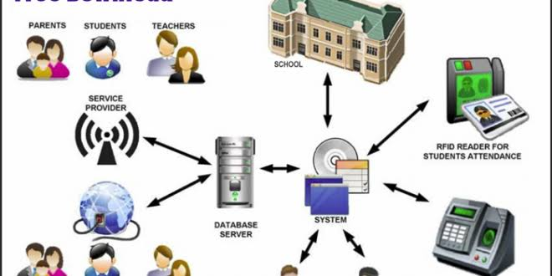**Resource Management :** School management oversees the allocation and utilization of resources such as finances, infrastructure, human resources, and educational materials to optimize their use and benefit the entire school community.

**Creating safe Environment:** It is crucial for school management to ensure a safe and secure environment for both students and staff. Implementing safety measures, addressing concerns promptly, and promoting a positive school culture are part of this purpose.

**Staff Development:**: School management supports the professional development of teachers and staff to enhance their teaching skills and overall effectiveness in the classroom.

**Stakeholder Communication :** Effective school management involves maintaining clear and open lines of communication with students, parents, teachers, staff, and the broader community. This fosters trust, cooperation, and a sense of involvement in the educational process.

**Policy Management :**School management implements educational policies and guidelines set by education boards or governing bodies. This ensures compliance with educational standards and legal requirements.

## 1.2- REASONS WHY SCHOOL MANAGEMENT IS IMPORTANT?

1. Attendance Record just in few clicks
2. Easy Home work Management
3. Better Exam Management
4. Effortless fee payment
5. Reviewing Student Performance
6. Better Communication

**LITERATURE SURVEY**

**EXISTING PROBLEM**

In the present School Management System, it is uneasy to store the information related to students, faculty and parents on the paper. As there is too many information when someone tries to access any of stored information it becomes a difficult and time-consuming task. While these days parents and faculty have more work than just take care of students it is difficult for both parents and faculty to monitor them. Whereas the storing and retrieving an information is a difficult task, it also requires much amount of unnecessary worker to do the task.

**PROPOSED PROBLEM**

The school management system will manage all the work in any school in particular order so that the time requirement and complexity of the system will be reduced, at first it will focus on student related information. As a student gets admission in the school system will start managing the details regarding the students. It will manage the fee details, and if the full payment has not been done, then it will notify about the fee to a staff of the school. School Management System will then display the date of the test and when the test completes it will display the results of the students. While the parents can use it to monitor their children’s performance, also they can contact the teachers.

**WHAT DOES THE SCHOOL MANAGEMENT SYSTEM INCLUDE ??**

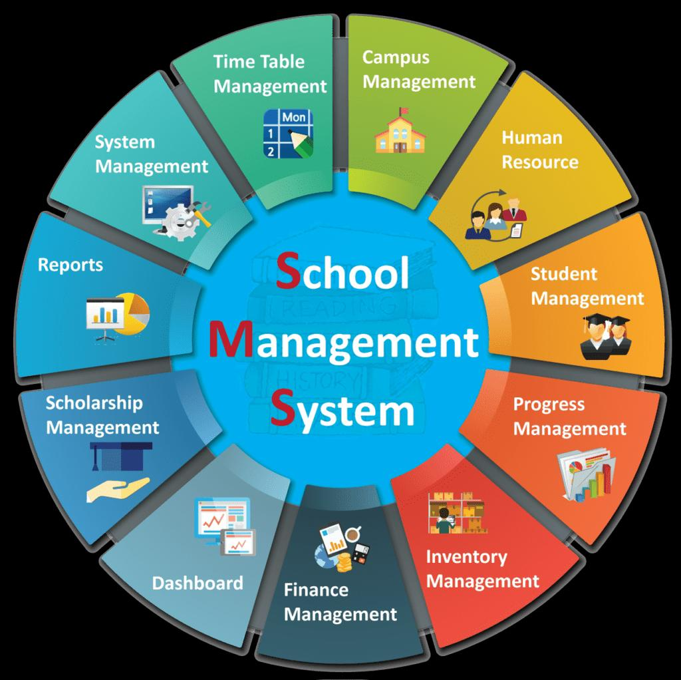A School Management System helps manage your day-to-day activities like data management, task scheduling, work reports, etc. In today’s time, one cannot effectively manage school activities without the School Management System. It provides you the ability to plan, manage and execute your strategies in such a way that shows desired results.

It provides different portals for different parties like students, parents, teachers, and high authority staff. So that the reporting and work can run smoothly.

* Maintenance and reporting of student data, including family, demographics, and other records.
* Processing inquiries from prospective students.
* Manage the admission or registration processes.
* Enrolling new students and activation of online scheduling.
* Managing extracurricular activities and/or related services.
* Monitoring & Registering of notes, remarks, incidents, and actions. (Educational CRM)
* Managing internal documents and Workflow.

# **THEORETICAL ANALYSIS**

**BLOCK DIAGRAM**

Object:Objects refer to the foundational data structures that store and organize data in the Salesforce platform. Objects can be standard, which are provided by Salesforce.

**Creation of objects in school management :**

**Create a school object -**

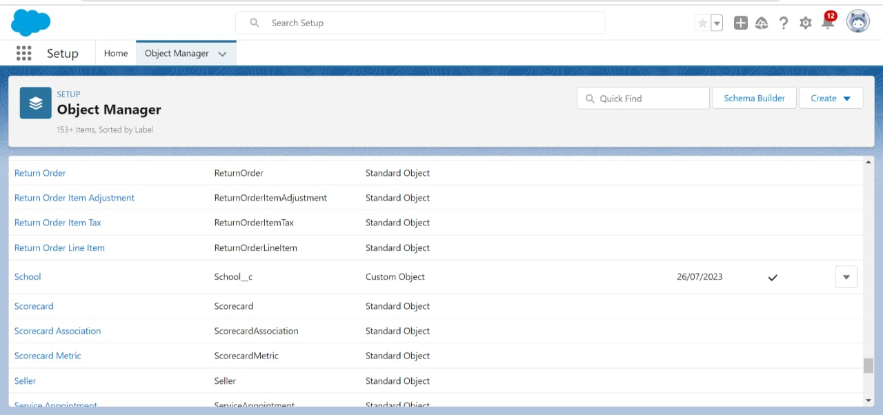

**Create a student object -**

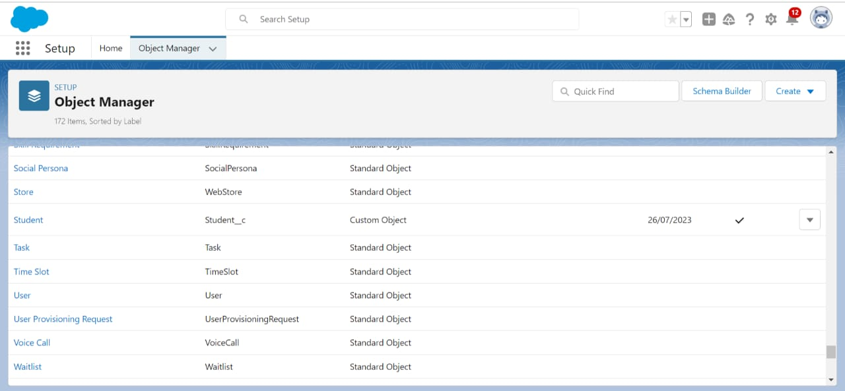

**Create a parent object -**

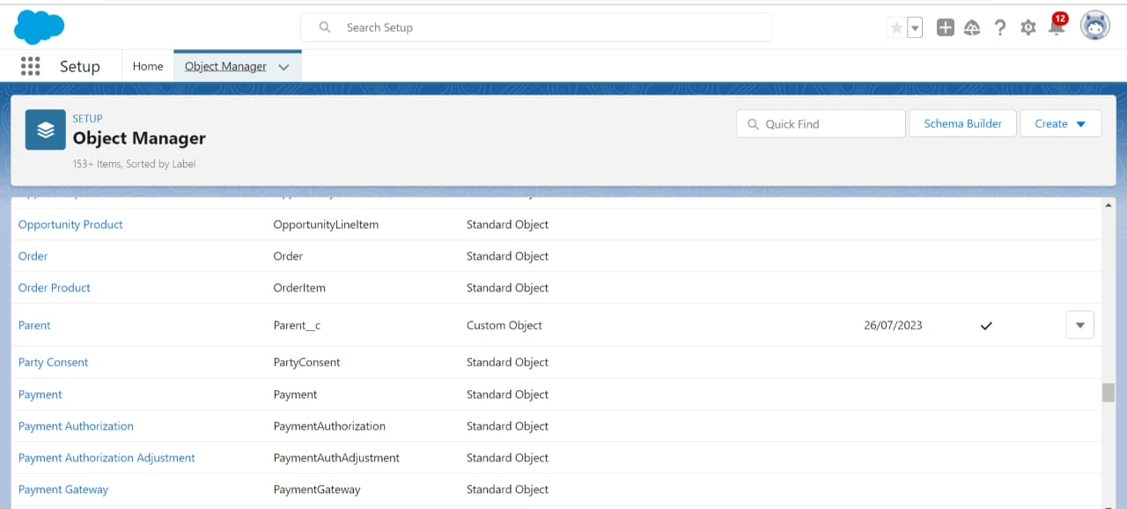

**Lightening App**

**App-**  A set of fields, objects, permissions, and functionally support a business process.

**Creation of School Management App-**

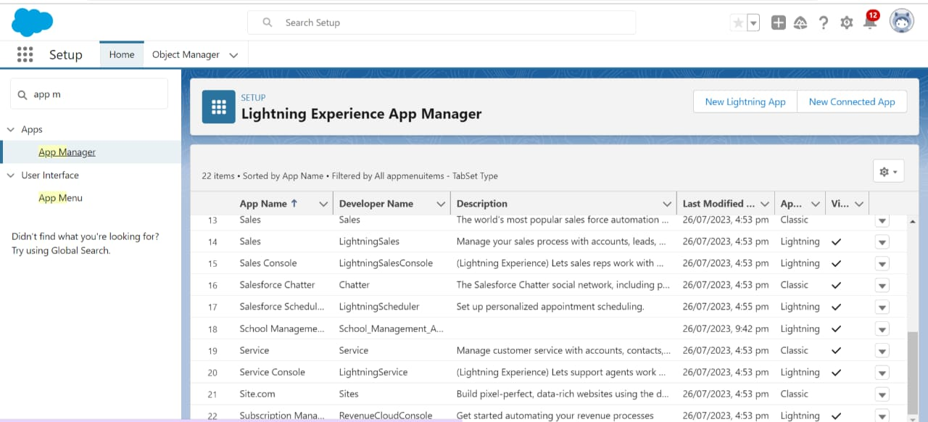

**Fields and Relationship**

An object relationship in Salesforce is a two-way association between two objects. Relationships are created by creating custom relationship fields on an object. This is done so that when users view records, they can also see and access related data.

**Creation of fields for School objects –**

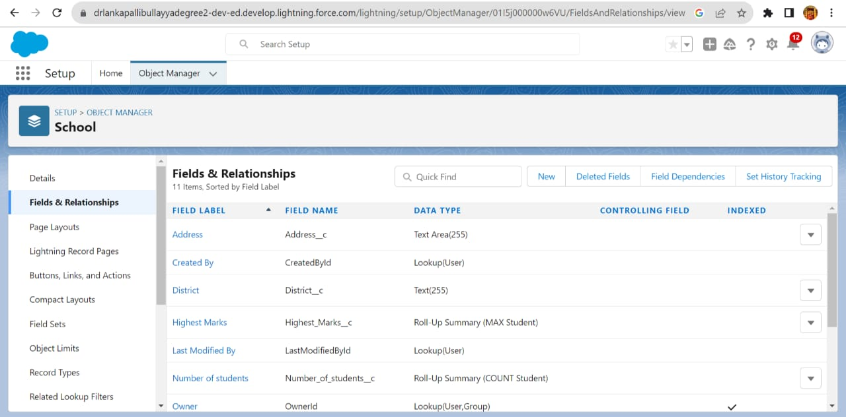

**Creation of fields for Student objects -**

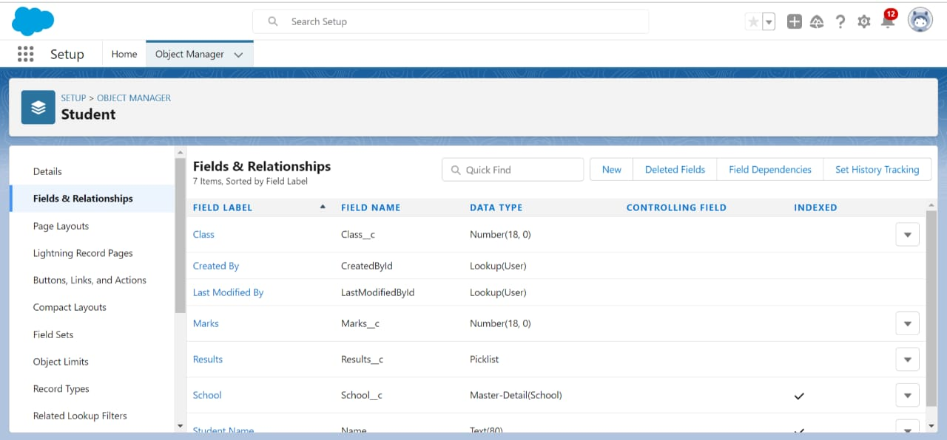

**Creation of fields for the Parent object**

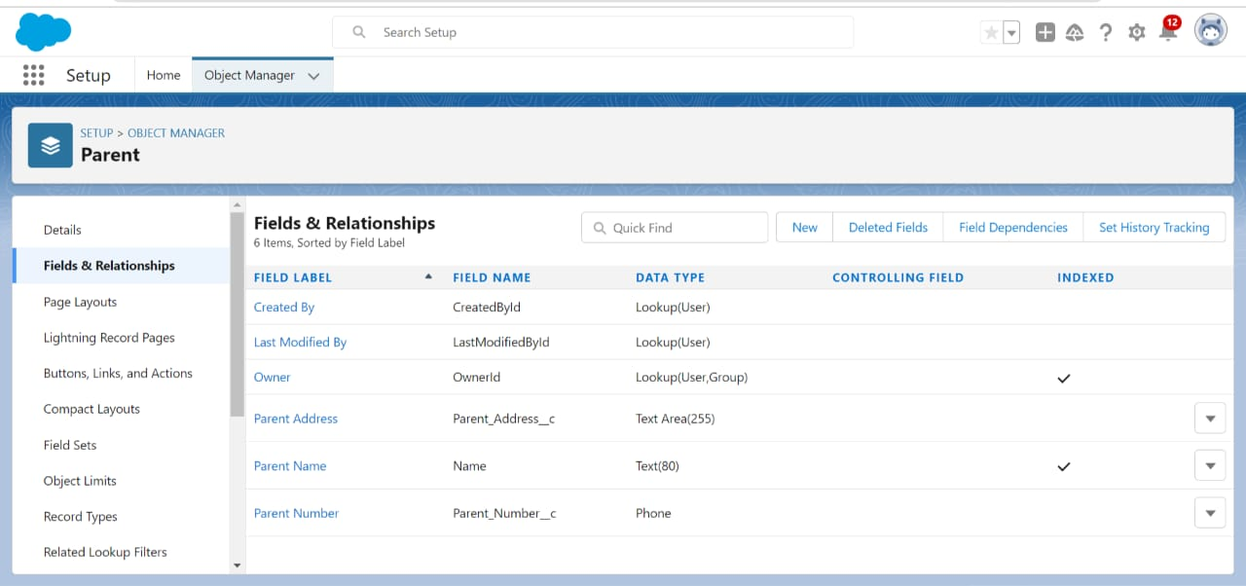

**Profiles**

A profile is a group/collection of settings and permissions that define what a user can do in Salesforce. A profile controls “Object permissions, Field permissions, User permissions, Tab settings, App settings, Apex class access, Visualforce page access, Page layouts, Record Types, Login hours & Login IP ranges

**Creation of profile -**

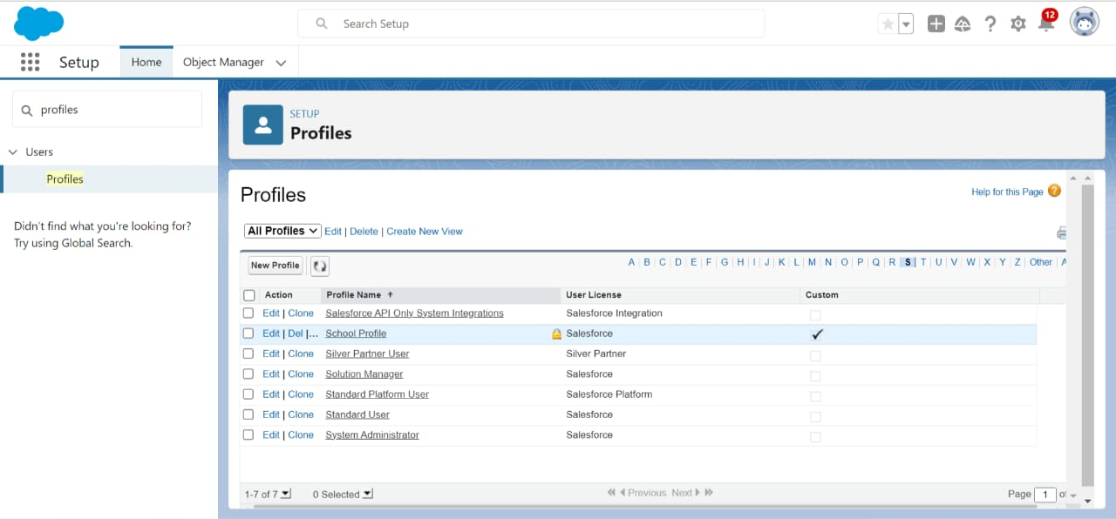

**Users:**

A user is anyone who logs in to Salesforce. Users are employees at your company, such as sales reps, managers, and IT specialists, who need access to the company's records.

**Creating a User -**

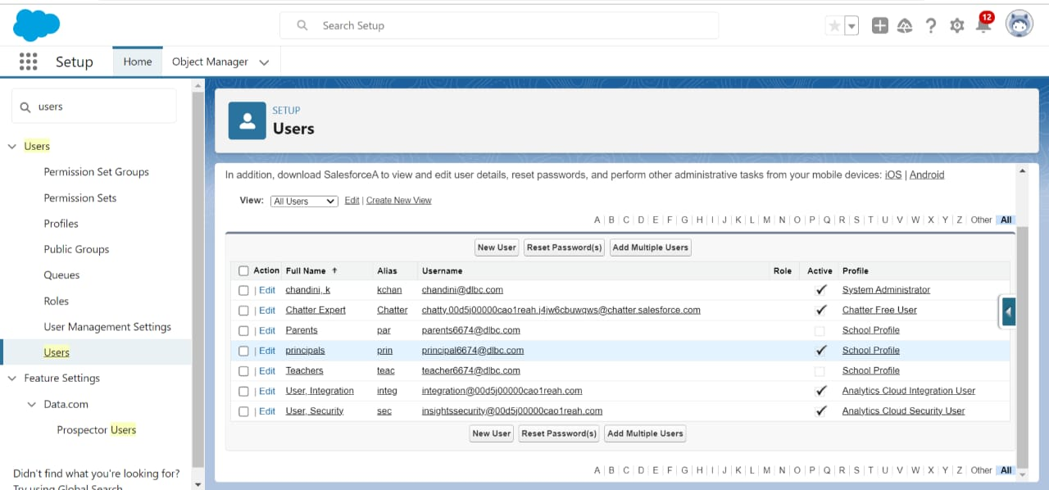

**Permissions sets**

**:** A permission set is a collection of settings and permissions that give users access to various tools and functions.

**Permission set of Teacher permission**

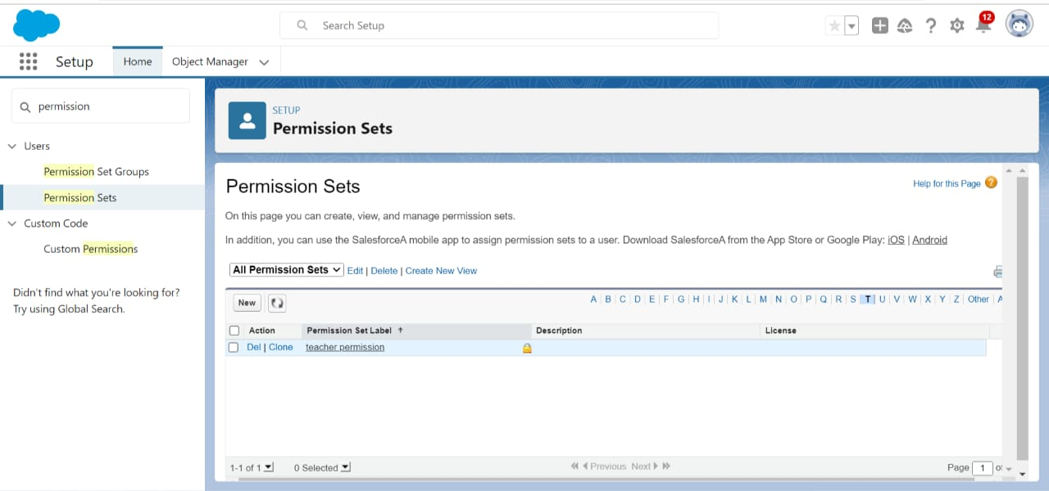

**Permission set of principal permission**

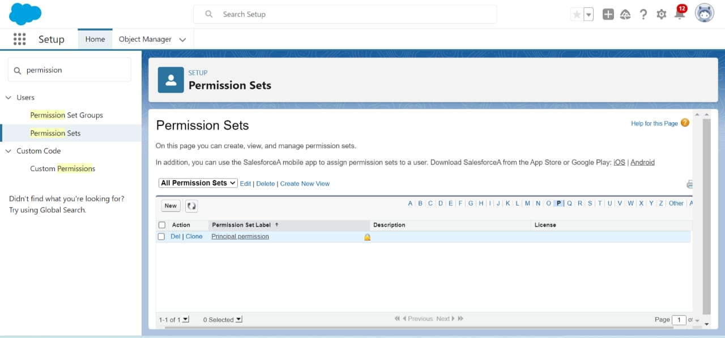

**USER ADOPTION**

**Record:-**

An item you’re tracking in your database, if your data is like a spreadsheet, then a record is a row on the spreadsheet.

**Create a Record (School)**

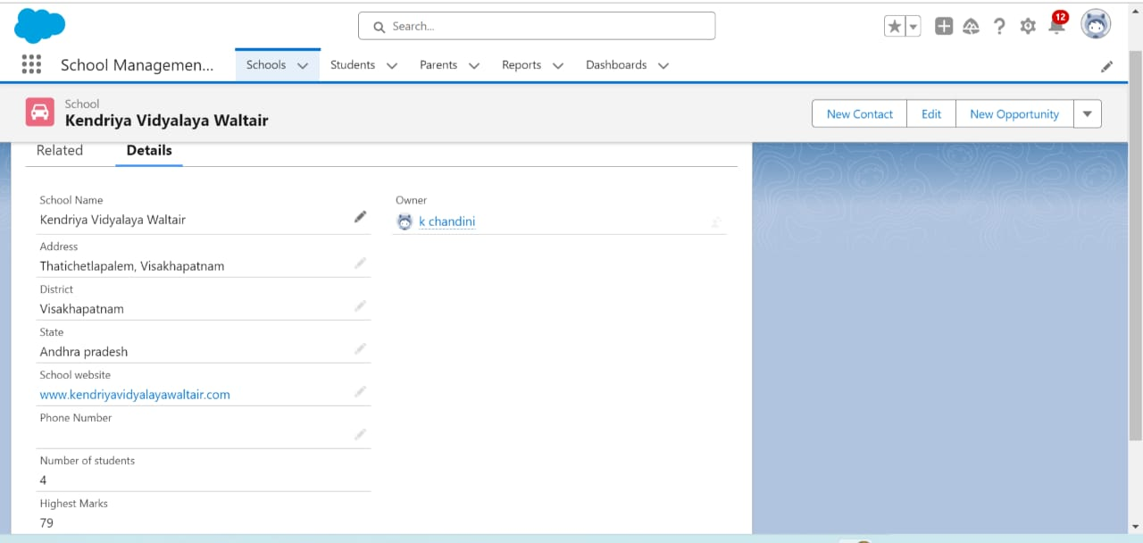

**View Record (school)**

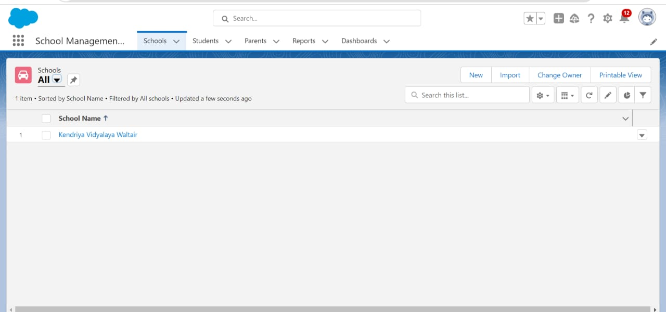

**RESULT**

**REPORTS**

Reports in Salesforce is a list of records that meet a particular criterion that answers a particular question. These records are displayed as a table that can be filtered or grouped based on any field.

**Create a Report (school)**

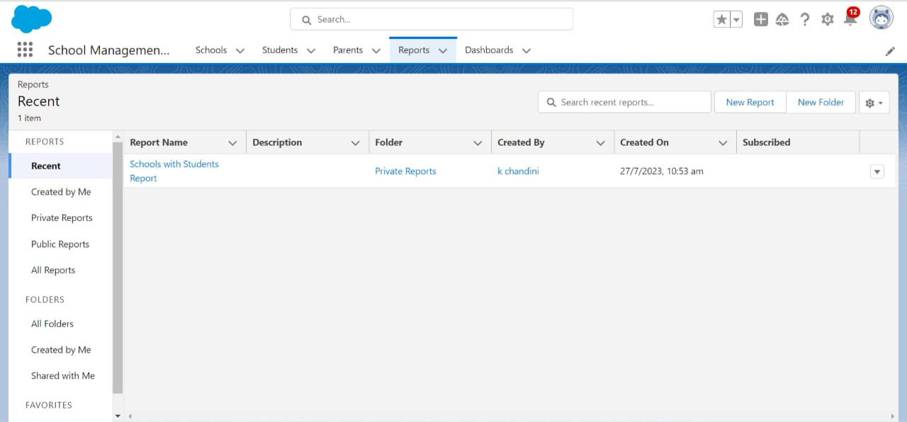

**View report ( School)**

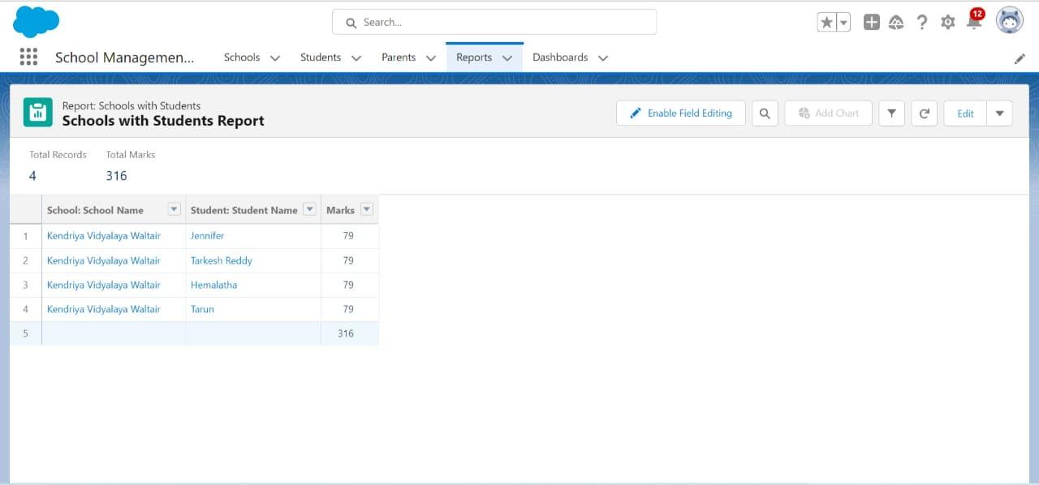

**ADVANTAGES**

* Increases Productivity.
* Engaging Classes.
* Easy-to-Access Student details.
* Comprehensive Digital Content.
* Generating Assessments.
* Quick Analysis of Tests.
* Makes the Admission Management Process Seamless.

**APPLICATIONS**

To build a comprehensive school management system, you would typically need to create several applications that work together to cover various aspects of school management. Here are some essential applications you might consider developing:

* **Student Information System (SIS):**: This application manages student data, including admissions, registrations, attendance, grades, and disciplinary records.
* **Teacher portal:** A platform for teachers to manage their classes, upload assignments, record grades, and communicate with students and parents.
* **Parent portal:** A portal for parents to access their child’s academic progress, attendance, and school announcements, and communicate with teachers and administrators.
* **Administrative Dashboard:**: An application for school administrators to oversee various aspects of the school, including managing staff, setting academic calendars, generating reports, and handling financial data.
* **Fee Management System:**: An application to handle fee collection, invoicing, and tracking of payments.
* **Transportation Management System:**: If the school provides transportation services, this application can be used to manage bus routes, schedules, and student ridership.
* **Examination and Grading System:**: An application to create and manage examinations, record, and calculate final grades.

**CONCLUSION**

In conclusion, a School Management System can play a critical role in improving academic success. School management systems are increasingly being used by educational institutions as a way to streamline administrative tasks and improve communication between teachers, students, and parents and provide access to valuable data, these systems can help create a more supportive and effective learning environment for students. School management systems are designed to meet the needs of modern-day educational institutions.